**Índex**  
  
1. Introduction………………………………………  
  
 1.1.Goals……………………………………….

2. Use Cases

2.1. Use Case Model

3. Use Case Application

1. **Introduction**

1.1 – This document specifies how the E-Lockers system, developed for managing Everis office lockers works.

1.2 –

**2. Use Cases**

**2.1 –** *Use Case Model*

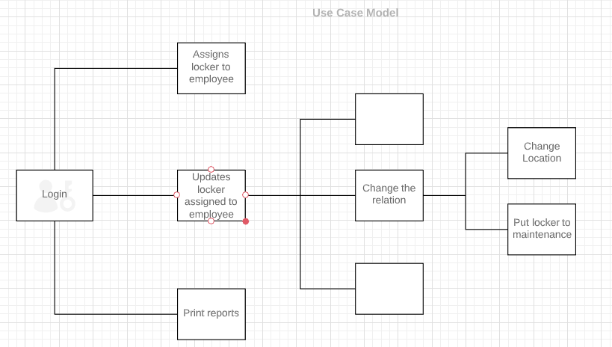

**3 – Assign locker to employee**

**3.1** – Login Page

**3.2** -